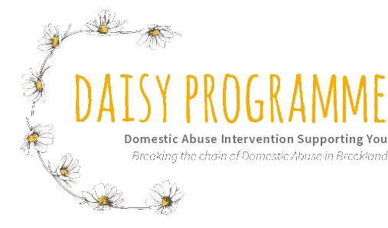

Referral Form and Initial Assessment
We only accept direct referrals for Standard risk. Referrals for High/Medium Risk must be sent to NIDAS. A referral form for professionals and self-referrals is available on their website. www.nidasnorfolk.co.uk

If you have a query or wish to discuss referring a Client to us, then please contact us on 01953 880903 or email help@daisyprogramme.org.uk

Has the Client been DASH Risk Assessed previously?

If so, what was their score? Date completed:

High Medium Standard

Has the Client ever been part of MARAC? (Multi Agency Risk Assessment Conference)
If so, when and are they still involved with MARAC?

Is/have they received support from any other Domestic Abuse organisations?
If so, whom and when?

Has the Client consented to their data/information being shared with Daisy Programme? YES / NO

Please complete the referral form as fully as possible. We aim to contact referrals within three working days of receipt. We will assess the needs and risks of the Client. We will contact you if there is an issue in accepting the client into Daisy Programme.

Referrer’s Contact Name & Number
NOTE: If you want to send a paper copy of the referral please post to Daisy Programme, Unit 1 Ventura House, Norwich Road, Watton, IP25 6JU. Email: help@daisyprogramme.org.uk

Name of referrer: Job title:

Name and address of agency:

Email address:

Telephone number:

Is client living with the perpetrator? |  |  |  |  | Yes / No
If no, when did they separate (if applicable)
When was the last incident of abuse?
Clients Name |  |  |  | DOB
 |  |  |  | Age
 |  |  |  | Language Spoken
 |  |  |  | Ethnic Origin
Client’s address: |  |  |  | Landline Telephone No:  Mobile Telephone No.
Email Address:
Please advise which gender the client identifies with
Please advise on clients sexual orientation
Employment Status: please specify
Is it safe to email and call and leave messages?

Best days and time to call

Names of person(s) responsible for the abuse |  |  |  |  |  | Relationship(s) to Client:
 |  |  |  |  |  | DOB
 |  |  |  |  |  | Address
Who lives at the Client’s address?

Name of child | DOB | Age | M/F | Non-resident parents name |  |  | Contact with child?
Does Client need any help to access our services? |  |  |  |  |  |  |  | Yes / No
If yes, please specify (disabilities/language/learning difficulties)

Client’s G.P. Details including Address and Phone Number

Please specify if Client is pregnant |  |  |  |  |  |  |  | Yes / No
Have the family had any contact with Children’s Services or Adult Social Care? |  |  |  |  |  |  |  | Yes / No
If yes, please can you give full details including name of social worker/family practitioner and what support is being offered:

Has there been or is there currently any police involvement? |  |  |  |  |  |  |  | Yes / No
If yes, please give details including crime numbers and dates of incidents

Are there any pending court hearings? |  |  |  |  |  |  |  | Yes / No
If so, what are they for? Criminal/child arrangements/non-molestation/financial

Does Client have support from any other agencies? |  |  |  |  |  |  |  | Yes / No
If yes, please specify and include their contact details

Does Client have support from family and friends? |  |  |  |  |  |  |  | Yes / No
If yes, please specify

Why are you referring this client to Daisy Programme?

What types of abuse are relevant |  |  |  |  | Physical  Emotional  Sexual  Financial  Coercive Control  Stalking & Harassment
Are there any immigration issues? |  |  |  |  |  | Yes / No
Please give details of the domestic abuse
Give details of domestic abuse history including contact details of other agencies/professionals involved.

Are there any other agencies are working with Client in respect of the abuse? |  |  |  |  |  | Yes / No
If so, please specify and include their contact details

We often find that people who have had similar experiences suffer with mental health problems, such as anxiety or depression. Has that happened?
If yes, please give details agencies involved including contact details and medication prescribed.

We also know that people who have had similar experiences may self-harm or use alcohol or drugs to cope. Does that apply? What does that look like, eg how long for and when was the most recent time?

