Policy 1 – Adult Safeguarding

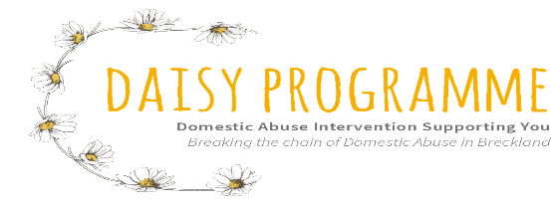
- Aim
To outline the practice and procedures for employees, volunteers, and trustees of Daisy Programme to contribute to the prevention of abuse of vulnerable adults through raising awareness and providing a clear framework for action when abuse is suspected.
The policy covers all employees, volunteers and trustees and should be used when a volunteer or employee suspects that a vulnerable adult is at risk of abuse. A survivor of domestic abuse/violence (DA/DV), may be a victim of abuse from the wider family members, neighbours, care employees etc. In most cases of this the police, Social Services and/or care agency will usually already be involved in dealing with the domestic violence incidents.
It should also be used if there are questions concerning the possibility that an adult referred to Daisy Programme has issues that might potentially bring them within the classification of a vulnerable adult, and these have not been recognised previously.
Daisy Programme is committed to work as part of a local, multi-agency suicide prevention programme. It supports practices and actions in line with National Suicide Prevention Strategy https://www.gov.uk/government/publications/suicide-prevention-strategyforengland with a focus on co-operating with primary care to create a safe environment for vulnerable individuals. Daisy Programme acknowledges that its work will employ evidence based preventative interventions that support high-risk groups by identifying the high risks and referring on.
Daisy Programme will not tolerate the abuse of adults in any of its forms and is committed to safeguarding adults with care and support needs from harm.
This policy outlines the steps Daisy Programme will make to safeguard an adult with care and support needs if they are deemed to be at risk or at risk. This policy sets out the roles and responsibilities of Daisy Programme in working together with other professionals and agencies in promoting the adult’s welfare and safeguarding them from abuse and neglect.
Daisy Programme will ensure that decisions made will allow adults to make their own choices and include them in any decision making. Daisy Programme will also ensure that safe and effective working practices are in place.
This policy is intended to support staff and volunteers working within Daisy Programme to understand their role and responsibilities in safeguarding adults. All staff and volunteers are expected to follow this policy.
The key objectives of this policy are for all employees and volunteers of Daisy Programme to:
- Have an overview of adult safeguarding.
- Be clear about their responsibility to safeguard adults.
- Ensure the necessary actions are taken where an adult with care and support needs is deemed to be at risk.
This policy is based on:
- The Care Act 2014 and the Care and Support statutory guidance.
- Norfolk County Council’s Safeguarding Adults
https://www.norfolk.gov.uk/caresupport-and-health/protecting-someone-fromharm/help-an-adult-at-risk-of-harm/reporta-concern

Under the Human Rights Act 1998, everyone has the right to live free from abuse and neglect. https://www.equalityhumanrights.com/en/human-rights/human-rights-act
Copies of this policy should be available within Daisy Programme and Daisy Programme will not tolerate the abuse of adults in the organisation and staff and volunteers should be made aware of how this policy can be accessed.
- What is Safeguarding Adults?
‘Safeguarding means protecting an adult’s right to live in safety, free from abuse and neglect. It is about people and organisations working together to prevent and stop both the risks and experience of abuse or neglect, while at the same time making sure that the adult’s wellbeing is promoted including, where appropriate, having regard to their views, wishes, feelings and beliefs in deciding on any action. This must recognise that adults sometimes have complex interpersonal relationships and may be ambivalent, unclear or unrealistic about their personal circumstances.’ Care and Support Statutory Guidance, Department of Health, updated February 2017.
All adults should be able to live free from fear and harm. But some may find it hard to get the help and support they need to stop abuse.
An adult may be unable to protect themselves from harm or exploitation due to many reasons, including their mental or physical incapacity, sensory loss or physical or learning disabilities. This could be an adult who is usually able to protect themselves from harm but maybe unable to do so because of an accident, disability, frailty, addiction, or illness.
Daisy Programme adheres to following the six key principles that underpin safeguarding work (See Care Act guidance).
- Empowerment
- Prevention
- Proportionality
- Protection
- Partnership
- Accountability
Daisy Programme will not tolerate the abuse of adults. Staff and volunteers should ensure that their work reflects the principles above and ensure the adult with care and support needs are involved in their decisions and informed consent is obtained. Daisy Programme should ensure that the safeguarding action agreed is the least intrusive response to the risk. Partners from the community should be involved in any safeguarding work in preventing, detecting, and reporting neglect and abuse. Daisy Programme should be transparent and accountable in delivering safeguarding actions.
- What is Making Safeguarding Personal (MSP)?
MSP means a case should be person-led and outcome-focused. The individual should be involved in identifying how best to respond to their safeguarding situation by giving them more choice and control as well as improving quality of life, wellbeing, and safety. Daisy Programme will ensure that adults are involved in their safeguarding arrangements and everyone is dealt with on a case-by-case basis. As adults may have different preferences, histories and lifestyles, the same process may not work for all.
- Who do adult safeguarding duties apply to?
The Care Act 2014 sets out that adult safeguarding duties apply to any adult who:
- Has care and support needs, and
- Is experiencing, or is at risk of, abuse and neglect, and
- Is unable to protect themselves from either the risk of, or the experience of abuse or neglect, because of those needs.
- Who do I go to if I am concerned?
The named responsible person for safeguarding duties for Daisy Programme is the Programme Director. All staff and volunteers should contact either the programme Director or the Deputy Safeguarding Lead who is the NIDAS Senior Idva for any concerns/queries they have regarding safeguarding adults. A log of the concern must be kept.
Programme Director will be responsible to make decisions about notifying adult social services if required and consider alternative actions, where necessary.
Programme Director will also ensure that the safeguarding policies and procedures are in place and up to date. They will ensure a safe environment is promoted for staff and volunteers and adults accessing the service.
Programme Director will ensure that Daisy Programme staff and volunteers are up to date with their safeguarding adults training. This will be refreshed annually.
- What should I do if I am concerned?
Staff and volunteers at Daisy Programme who have any adult safeguarding concerns should:
1. Respond
- Take emergency action if someone is at immediate risk of harm/in need of urgent medical attention. Dial 999 for emergency services.
- Get brief details about what has happened and what the adult would like done about it, but do not probe or conduct a mini investigation.
- Seek consent from the adult to act and to report the concern. Consider whether the adult may lack capacity to make decisions about their own and other people’s safety and wellbeing. If you decide to act against their wishes or without their consent, you must record your decision and the reasons for this.

2. Report
- Report to The Daisy Programme Designated Safeguarding Lead (Programme Director). Follow the flowchart on Page 7.
3. Record
- Complete the relevant safeguarding notification form and log of incident.
- As far as possible, records should be written as they have happened, dated, and signed.
- Records about safeguarding concerns are confidential and kept in the locked office filing cabinet. Access should not be given to any unauthorised person.
4. Refer
In deciding whether to refer or not, the Designated Safeguarding Lead will take into account:
- The adult’s wishes and preferred outcome.
- Whether the adult has mental capacity to make an informed decision about their own and others’ safety.
- The safety or wellbeing of children or other adults with care and support needs.
- Whether there is a person in a position of trust involved.
- Whether a crime has been committed.
This should inform the decision whether to notify the concern to the following people:
- Norfolk Constabulary if a crime has been committed and/or
- Norfolk County Council’s Adult Social services for possible safeguarding enquiry.
- Relevant regulatory bodies such as Care Quality Commission, Ofsted, Charities commission.
- Service commissioners.
- Family/relatives as appropriate (seek advice from adult social services).
The Designated Safeguarding Lead should keep a record of the reasons for referring the concern or reasons for not referring. Incidents of abuse may be one-off or multiple and may affect one person or more. Staff and volunteers should look beyond single incidents to identify patterns of harm. Accurate recording of information will also assist in recognising any patterns.
- What are your roles and responsibilities?
All staff, management, trustees, and volunteers at Daisy Programme are expected to report any concerns to the named person for safeguarding. If the allegation is against one of Daisy Programme staff, volunteers, trustees, or directors, seek advice from Daisy Programme Designated Safeguarding Lead. If the allegation is against the Safeguarding Lead, seek advice from Norfolk County Council’s Adult Social Services Team.
The Designated Safeguarding Lead will be responsible for providing acknowledgement of the referral and brief feedback to the person raising the original concern. Feedback should be given in a way that will not make the situation worse or breach the Data Protection Act. If the police are involved, they should be consulted prior to giving feedback to the referrer to ensure any criminal investigation is not affected.
The local authority will decide on who will lead on a safeguarding enquiry should it progress to that stage. The Daisy Programme will not conduct its own safeguarding enquiry unless instructed to do so by the local authority.
Staff and volunteers should ensure as far as possible that the adult with care and support needs is involved at all stages of their safeguarding enquiry so that a person-centred approach is adopted.
- Complaints Procedure
Daisy Programme promotes transparency and honesty when things go wrong. All staff and volunteers should apologise and be honest with service users and other relevant people when things go wrong. For service users - See Complaints Policy (Policy 14). If a staff or volunteer or any other member of the organisation is unhappy with Daisy Programme decision about the safeguarding concern, refer them to Grievance Policy (Policy 11).
Daisy Programme is committed to ensuring that staff and volunteers who in good faith whistle-blow in the public interest, will be protected from reprisals and victimisation, see Whistleblowing Policy (Policy 3).
The Mental Capacity Act 2005 is to be used when decisions on behalf of those adults with care and support needs who are unable to make some decisions for themselves. Refer to the Mental Capacity Act Code of Practice, https://www.gov.uk/government/publications/mental-capacity-act-code-of-practice. You may need to involve an advocate if the person lacks capacity to make decisions about the safeguarding concern.
- Why is it important to act?
It may be difficult for adults with care and support needs to protect themselves and to report abuse. They rely on you to help them.
- Confidentiality and information sharing
Daisy Programme expects all staff, volunteers, and trustees to always maintain confidentiality. In line with Data Protection law, Daisy Programme does not share information if not required. It should however be noted that information should be shared with authorities if an adult is deemed to be at risk of harm. Sharing the right information, at the right time, with the right people can make all the difference to preventing harm. For further guidance on information sharing and safeguarding see: https://www.scie.org.uk/care-act-2014/safeguarding-adults/sharing-information/keymessages.asp
- Recruitment and selection
- Safe recruitment and selection practice is vital to safeguarding and protecting vulnerable adults.
- All staff and volunteers are carefully selected. Daisy Programme’s recruitment procedures are in line with the NSAB safer recruiting guidelines.
- DBS checks are carried out in accordance with legislation for all staff, student on placements, volunteers, and session counsellors before they can work with us.
- DBS disclosures are recorded in staff and volunteer files.
- To review DBS checks of volunteers and employees every three years from the date of initial DBS check completed.
- To review the Policy, practices, and training at least every 12 months and update as necessary.
- All new members of staff, volunteers, students on placement and session counsellors complete the induction process and sign to agree they have understood our policies, procedures, and basic safeguarding practices.
- Training, awareness raising and supervision
Daisy Programme will ensure that all staff and volunteers receive training on safeguarding adults. All staff and volunteers should be clear regarding the core values of Daisy Programme and our commitment to safeguarding adults. It is the responsibility of staff and volunteers to attend training and read any updated briefing material they receive.
Similarly, staff and volunteers may encounter concerns about the safety and wellbeing of children. For more information about children’s safeguarding, refer to Children’s Safeguarding Policy (Policy 2).

- Prevent
Radicalisation and extremism of adults with care and support needs is a form of emotional/psychological exploitation. Radicalisation can take place through direct personal contact, or indirectly through social media. If staff are concerned that an adult with care and support needs is at risk of being radicalised and drawn into terrorism, they should treat it in the same way as any other safeguarding concern. For more information about Prevent see: https://www.gov.uk/government/publications/prevent-duty-guidance
- Related Policies
Please see: Policy 2 Child Safeguarding
- Policy Review
This policy will be reviewed annually.

DATE OF REVIEW | REASON FOR REVIEW | CHANGES MADE | DATE OF NEXT REVIEW
01/09/2023

Appendix 1
What are the types of Safeguarding Adults Abuse?
The Care and Support statutory guidance sets out the 10 main types of abuse:
- Physical abuse.
- Neglect.
- Sexual abuse.
- Psychological.
- Financial abuse.
- Discriminatory.
- Organisational.
- Modern Slavery.
- Self-neglect.
However, you should keep an open mind about what constitutes abuse or neglect as it can take many forms and the circumstances of the individual case should always be considered.
What are the possible signs of abuse?
Abuse and neglect can be difficult to spot. You should be alert to the following possible signs of abuse and neglect:
- Depression, self-harm or suicide attempts.
- Difficulty making friends.
- Fear or anxiety.
- The person looks dirty or is not dressed properly.
- The person never seems to have money.
- The person has an injury that is difficult to explain (such as bruises, finger marks, ‘non accidental’ injury, neck, shoulders, chest and arms).
- The person has signs of a pressure ulcer.
- The person is experiencing insomnia.
- The person seems frightened or frightened of physical contact.
- Inappropriate sexual awareness or sexually explicit behaviour.
- The person is withdrawn, changes in behaviour.
You should ask the person if you are unsure about their well-being as there may be other explanations to the above presentation.
Who abuses and neglects adults?
Abuse can happen anywhere, even in somebody’s own home. Most often abuse takes place by others who are in a position of trust and power. It can take place whether an adult lives alone or with others. Anyone can carry out abuse or neglect, including:
- Partners.
- Other family members.
- Neighbours.
- Friends.
- Acquaintances.
- Local residents.
- People who deliberately exploit adults they perceive as vulnerable to abuse.
- Paid staff or professionals.
- Volunteers and strangers.
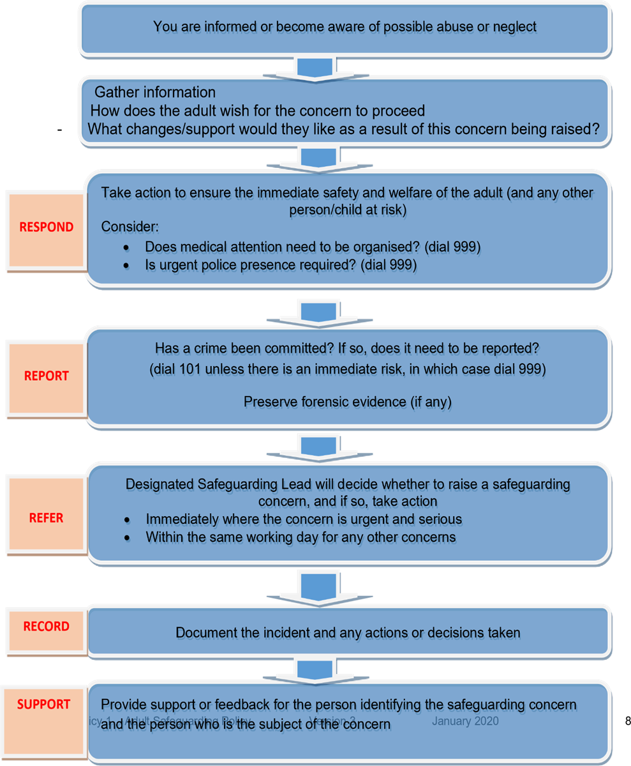
Raising a safeguarding concern

